# ASSIGNMENT – 1

**NAME : NALLALA SIRI**

**HALL TICKET NO : 2403A52037**

**BATCH NO : AIB03**

**TASK 1 :**

Write a comment: # Function to check if a string is a valid palindrome (ignoring  
spaces and case) and allow Copilot to complete it.

**PROMPT :**

Write a comment: # Function to check if a string is a valid palindrome (ignoring spaces and case)

**CODE :**

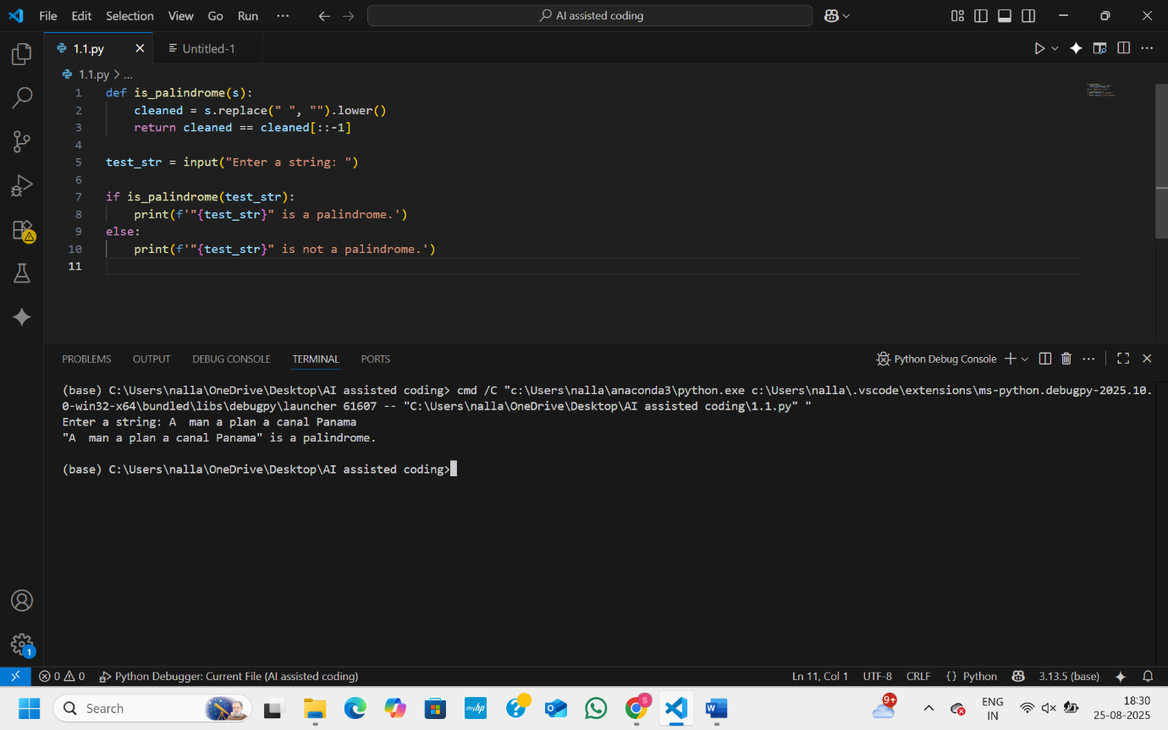

**OBSERVATION :**

This program is used to check whether a given string is a palindrome. A palindrome is a word or sentence that reads the same forward and backward, ignoring spaces and letter case. The program first defines a function that removes spaces from the input, converts all characters to lowercase, and then checks if the cleaned string is equal to its reverse. After this, it asks the user to enter a string and passes it to the function. Based on the result, it prints whether the original string entered by the user is a palindrome or not. For example, if the user types “madam” or “A man a plan a canal Panama,” the program will say it is a palindrome, while typing “hello” will result in saying it is not.

**TASK 2 :**

Generate a Python function that returns the Fibonacci sequence up to n terms. Prompt with only a function header and docstring.

**PROMPT :**

Generate a Python function that returns the Fibonacci sequence up to n terms.

**CODE :**

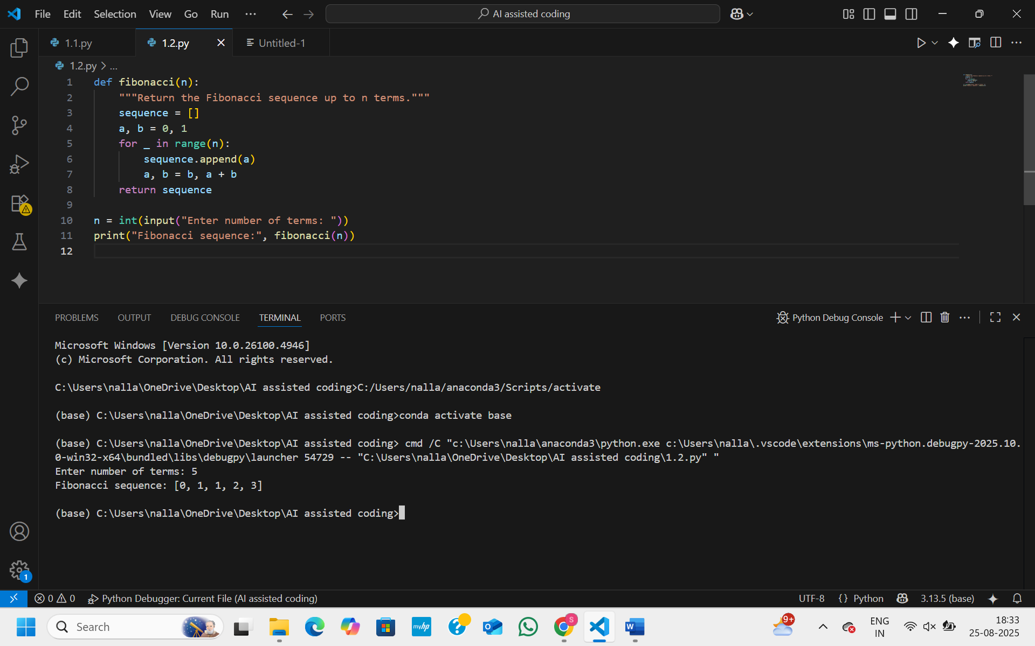

**OBSERVATION :**

This program generates the Fibonacci sequence up to the number of terms given by the user. The Fibonacci sequence starts with 0 and 1, and each new number is the sum of the previous two. In the program, two variables a and b are used to hold consecutive terms, starting with 0 and 1. Inside a loop that runs n times, the current value of a is added to the sequence, and then a and b are updated so that a takes the value of b and b becomes the sum of the two. After the loop ends, the complete sequence is returned. Finally, the program asks the user for the number of terms, calls the function, and prints the Fibonacci sequence. For example, if the user enters 5, the program will output 0, 1, 1, 2, 3.

**TASK 3 :**

Write a comment like # Function to reverse a string and use Copilot to generate the function.

**PROMPT :**

Write a comment like # Function to reverse a string .

**CODE :**

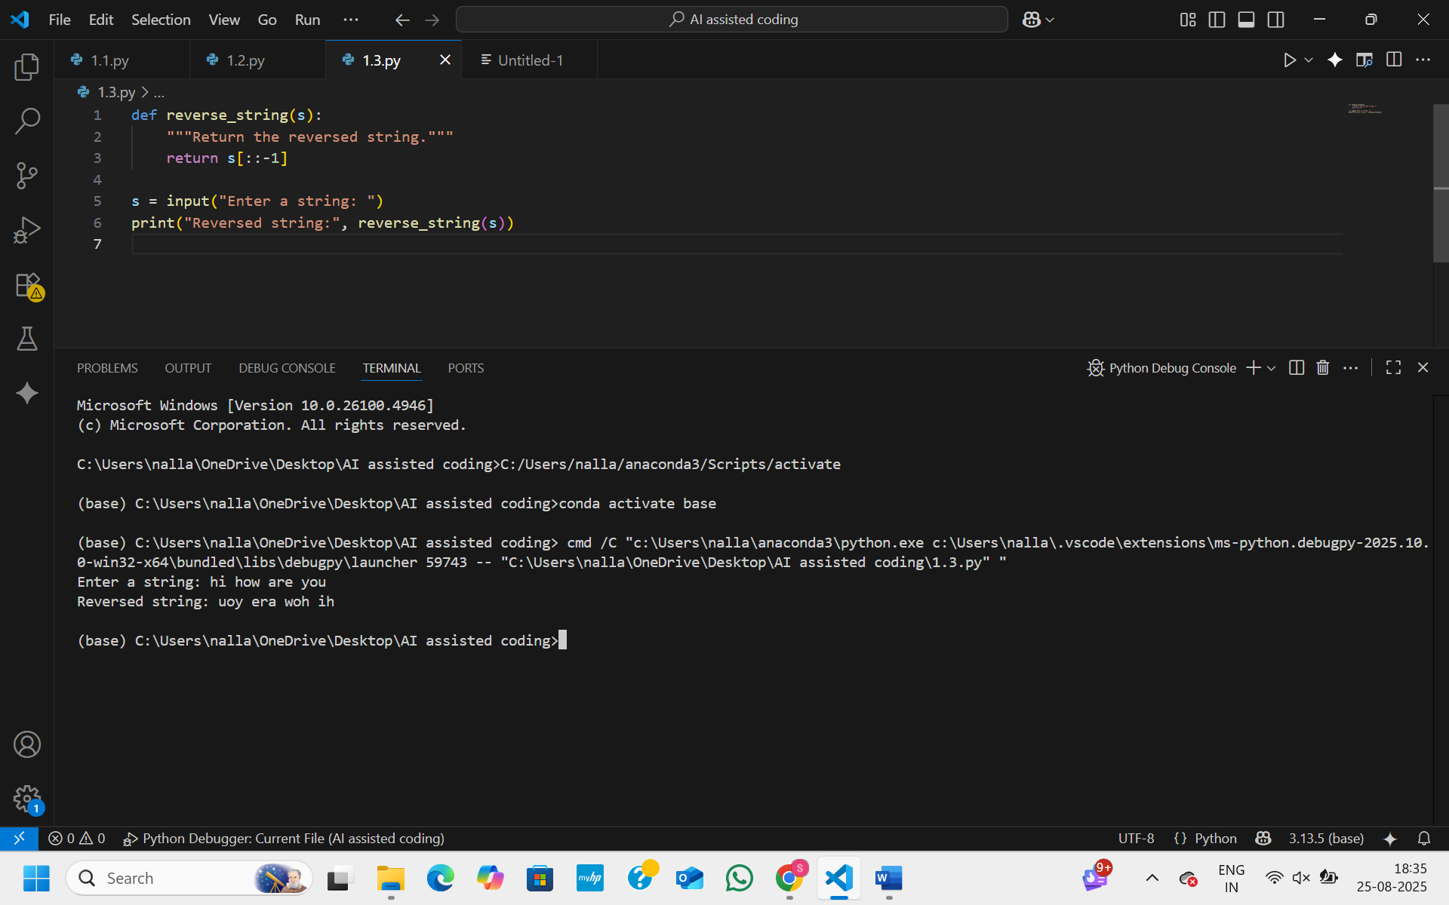

**OBSERVATION :**

This program is used to reverse a string.It defines a function reverse_string(s) that takes a string as input.Inside the function, s[::-1] is used to reverse the string.The program then asks the user to enter a string.  
Finally, it calls the function and prints the reversed string.

**TASK 4 :**

Generate a program that simulates a basic calculator (add, subtract, multiply, divide).

**PROMPT :**

Generate a program that simulates a basic calculator (add, subtract, multiply, divide).  
Write the comment: # Simple calculator with 4 operations .

**CODE :**

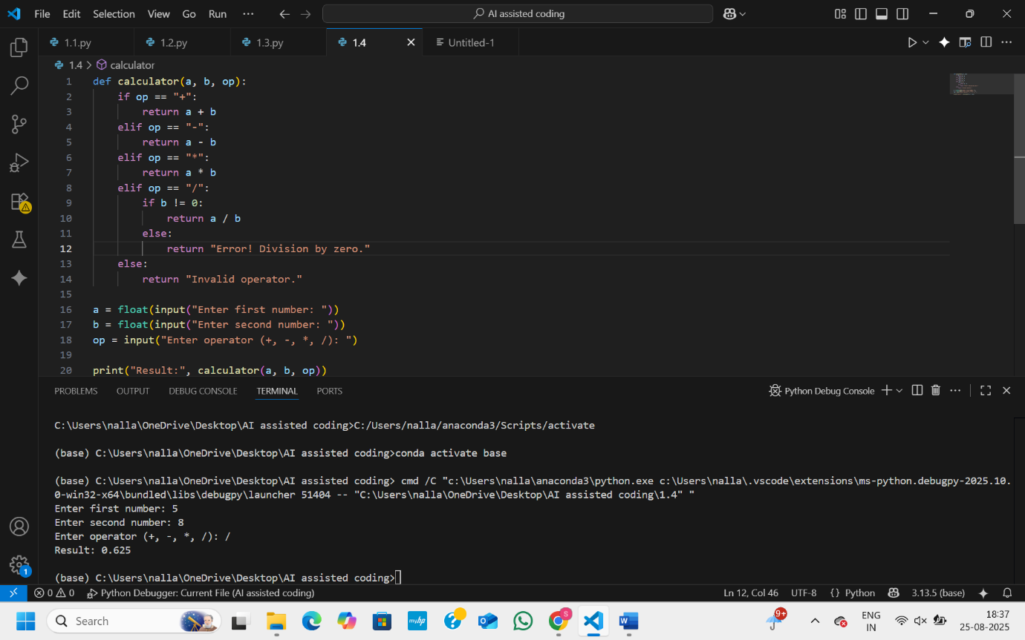

**OBSERVATION :**

This program works as a simple calculator.It defines a function calculator(a, b, op) that takes two numbers and an operator.  
Based on the operator, it performs addition, subtraction, multiplication, or division.It also checks for division by zero and returns an error if it happens.  
Finally, the program takes input from the user and displays the result.

**TASK 5 :**

Use a comment to instruct AI to write a function that reads a file and returns the number of lines.

**PROMPT :**

Genereate a function that reads a file and returns the number of lines.

**CODE :**

